Extra Feature – Match Making Website

Users are able to request to connect with another user. The other user would then need to accept or reject this request. If the user accepts the friend request, they will receive a notification.

# Explanation – User account (Shu)

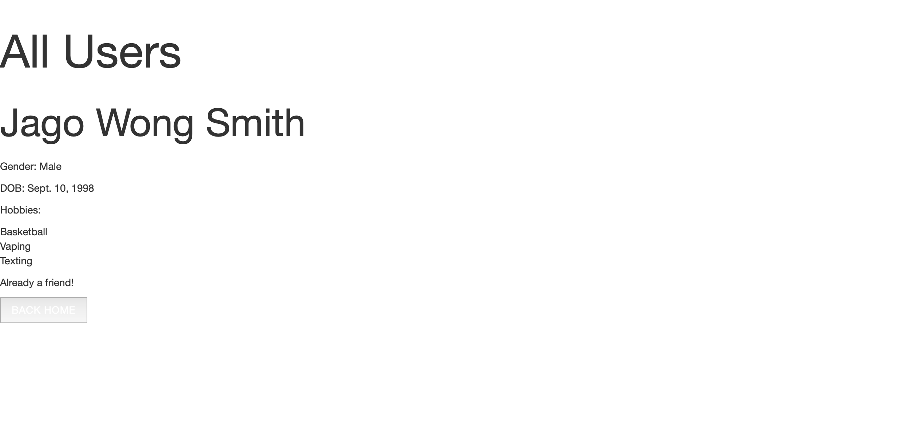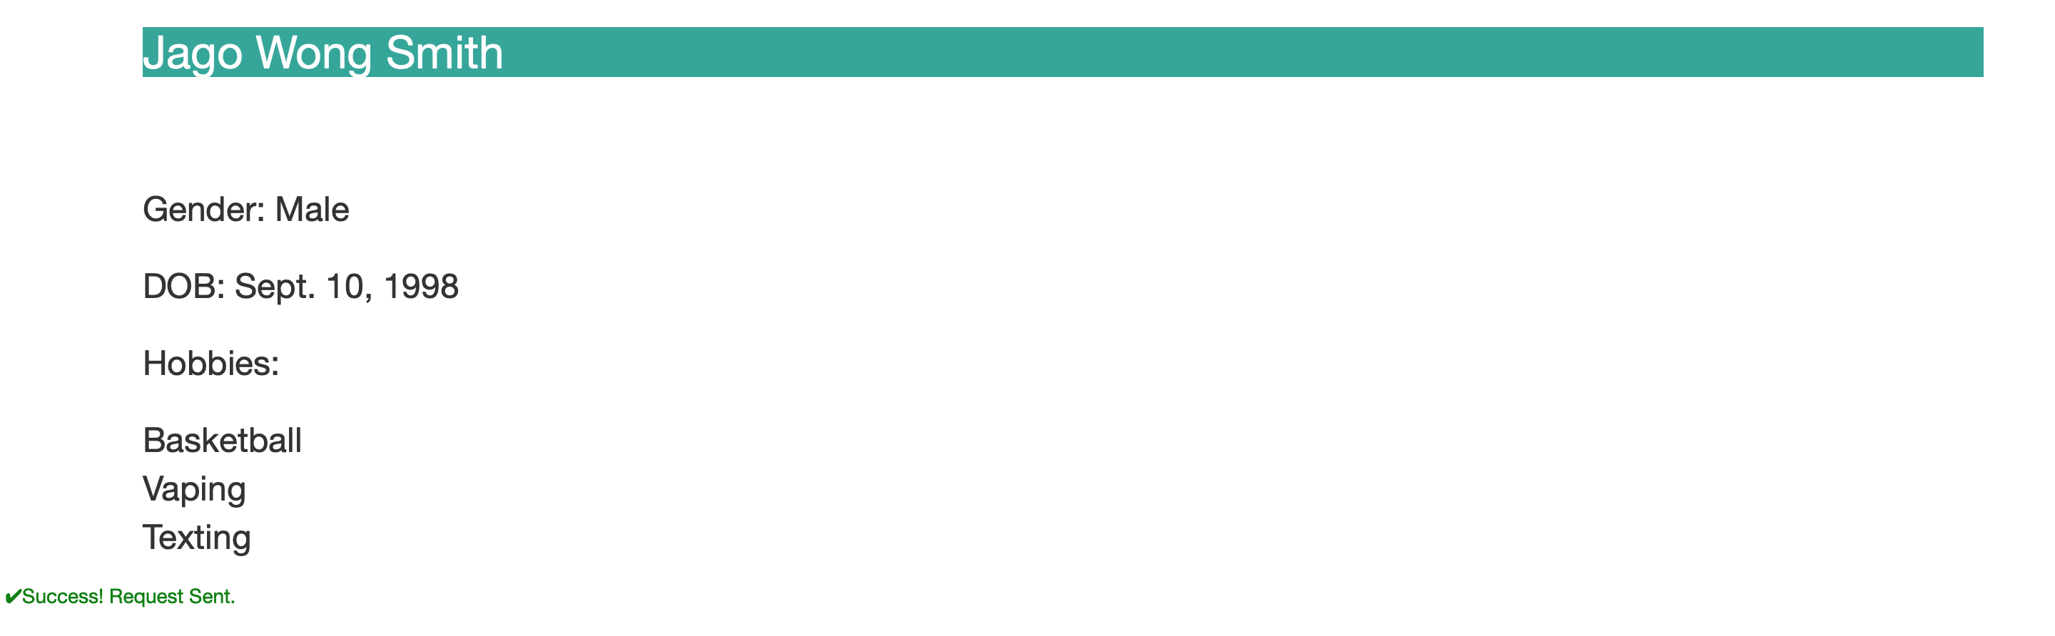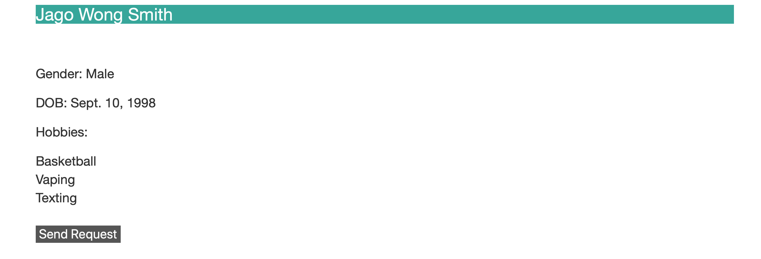

1. The user (Shu) views a list of all the user accounts on the site. From the list, the user picks another user to connect with by sending a friend request (to the user Jago).
2. After the user clicks on the button ‘send request, a notification appears stating ‘Success! Request sent.’
3. If the user ‘Jago’ accepts the friend request, then Jago will appear on Shu’s friends list, displaying the statement ‘Already a friend!’
4. If the other user rejects the request, the ‘all users’ page will be blank – Jago will not appear as a friend.

# Explanation – User account (Jago)

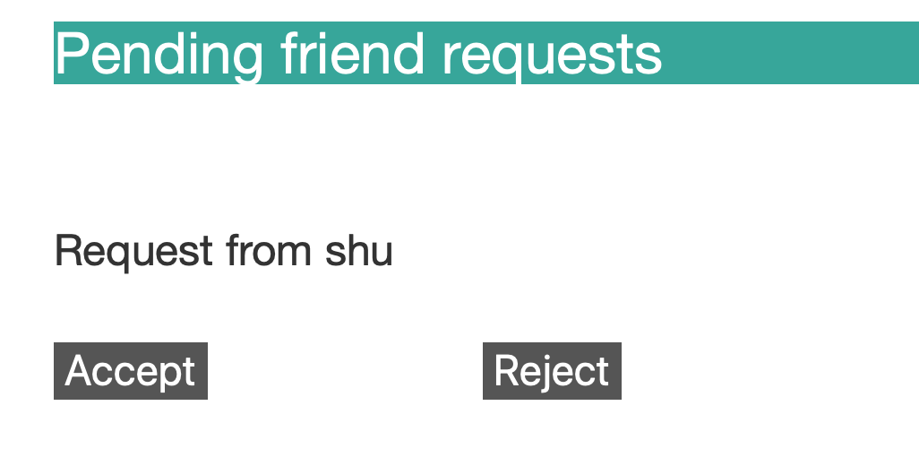

1. The user ‘Jago’ receives a friend request from another user (Shu) on the site.
2. The user has two options – to accept or reject
3. When the user (Jago) clicks on either of these options, a message will be displayed stating ‘Success! Response sent.’